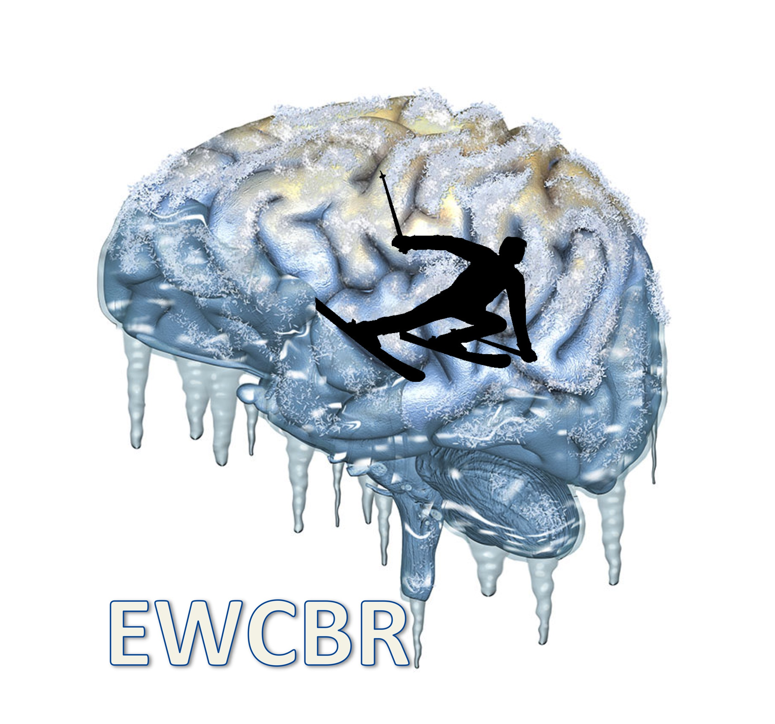
EWCBR 2023 / REGISTRATION AND ACCOMMODATION FORM
4 – 11 MARCH 2023

REGISTRATION FORM

To be sent by mail to: ewcbr2017@gmail.com

NAME: FIRST NAME:

INSTITUTION:

CITY: COUNTRY:

TELEPHONE: E-MAIL:

A) REGISTRATION FEES

‐ Payment from Institutions or Universities 260€
after Jan 31st 2023 300€

‐ Others (pharmaceutical companies...) 400€
after Jan 31st 2023 450€

‐ Junior scientist invited in a session 50€

‐ Accompanying person 50€

TOTAL A= €
B) ACCOMMODATION:
Ο I wish to have a private room
Ο I wish to share a double room with (please indicate)**:………..

** Only for participants arriving and leaving on the same dates with simultaneous payments. We do not organize the sharing, so get organized with your room mate

Accommodation at Eurotel, Les Diablerets Switzerland:
Priority will be given to those booking the entire package including 7 nights.
The package (from dinner March 4th to breakfast March 11th) includes complete
hotel services and half- board (breakfast and dinner).

Package for the entire meeting:
O Double room: 1 015€/person or ........x 145€/night# + 15€ (booking and admin fees)##

O Single room: 1 225€ or ........x 175€/night# + 15€ (booking and admin fees)##

#If you do not book the entire package, please indicate your exact dates of arrival and departure:
##: only add the 15€ admin fee if you do not book the entire package

TOTAL B = €

TOTAL A+B = €

• PAYMENT BY CHECK (French participants and from Euro Zone countries): to PROMOTION DES NEUROSCIENCES EUROPEENNES
to be sent to C. Baunez, Promotion des neurosciences européennes, 8 traverse Fontaine de Caylus 13002 Marseille, France.
• PAYMENT BY BANK TRANSFER (others): to the following bank account: B.N.P. (BANQUE NATIONALE DE PARIS) Agence St Ferreol, Rue St Ferréol, 13001 Marseille
Account no. 30004‐01841‐00005317896‐83. (EUROCHECKS WILL NOT BE ACCEPTED)
IBAN: FR76 3000 4018 4100 0053 1789 683
IMPORTANT: MAKE SURE YOUR NAME APPEARS ON THE BANK TRANSFER AND SELECT THE OPTION TO PAY YOURSELF FOR THE TRANSFER FEES
NEW! PAYMENT By PAYPAL is possible but will imply fees to be paid cash onsite. Email address to use: ewcbr2017@gmail.com , please contact treasurer before proceeding (christelle.baunez@univ-amu.fr or ewcbr2017@gmail.com )
Notes: Be aware that cancellation of booking will lead to only partial reimbursement, as we have to pay the hotel in advance.

