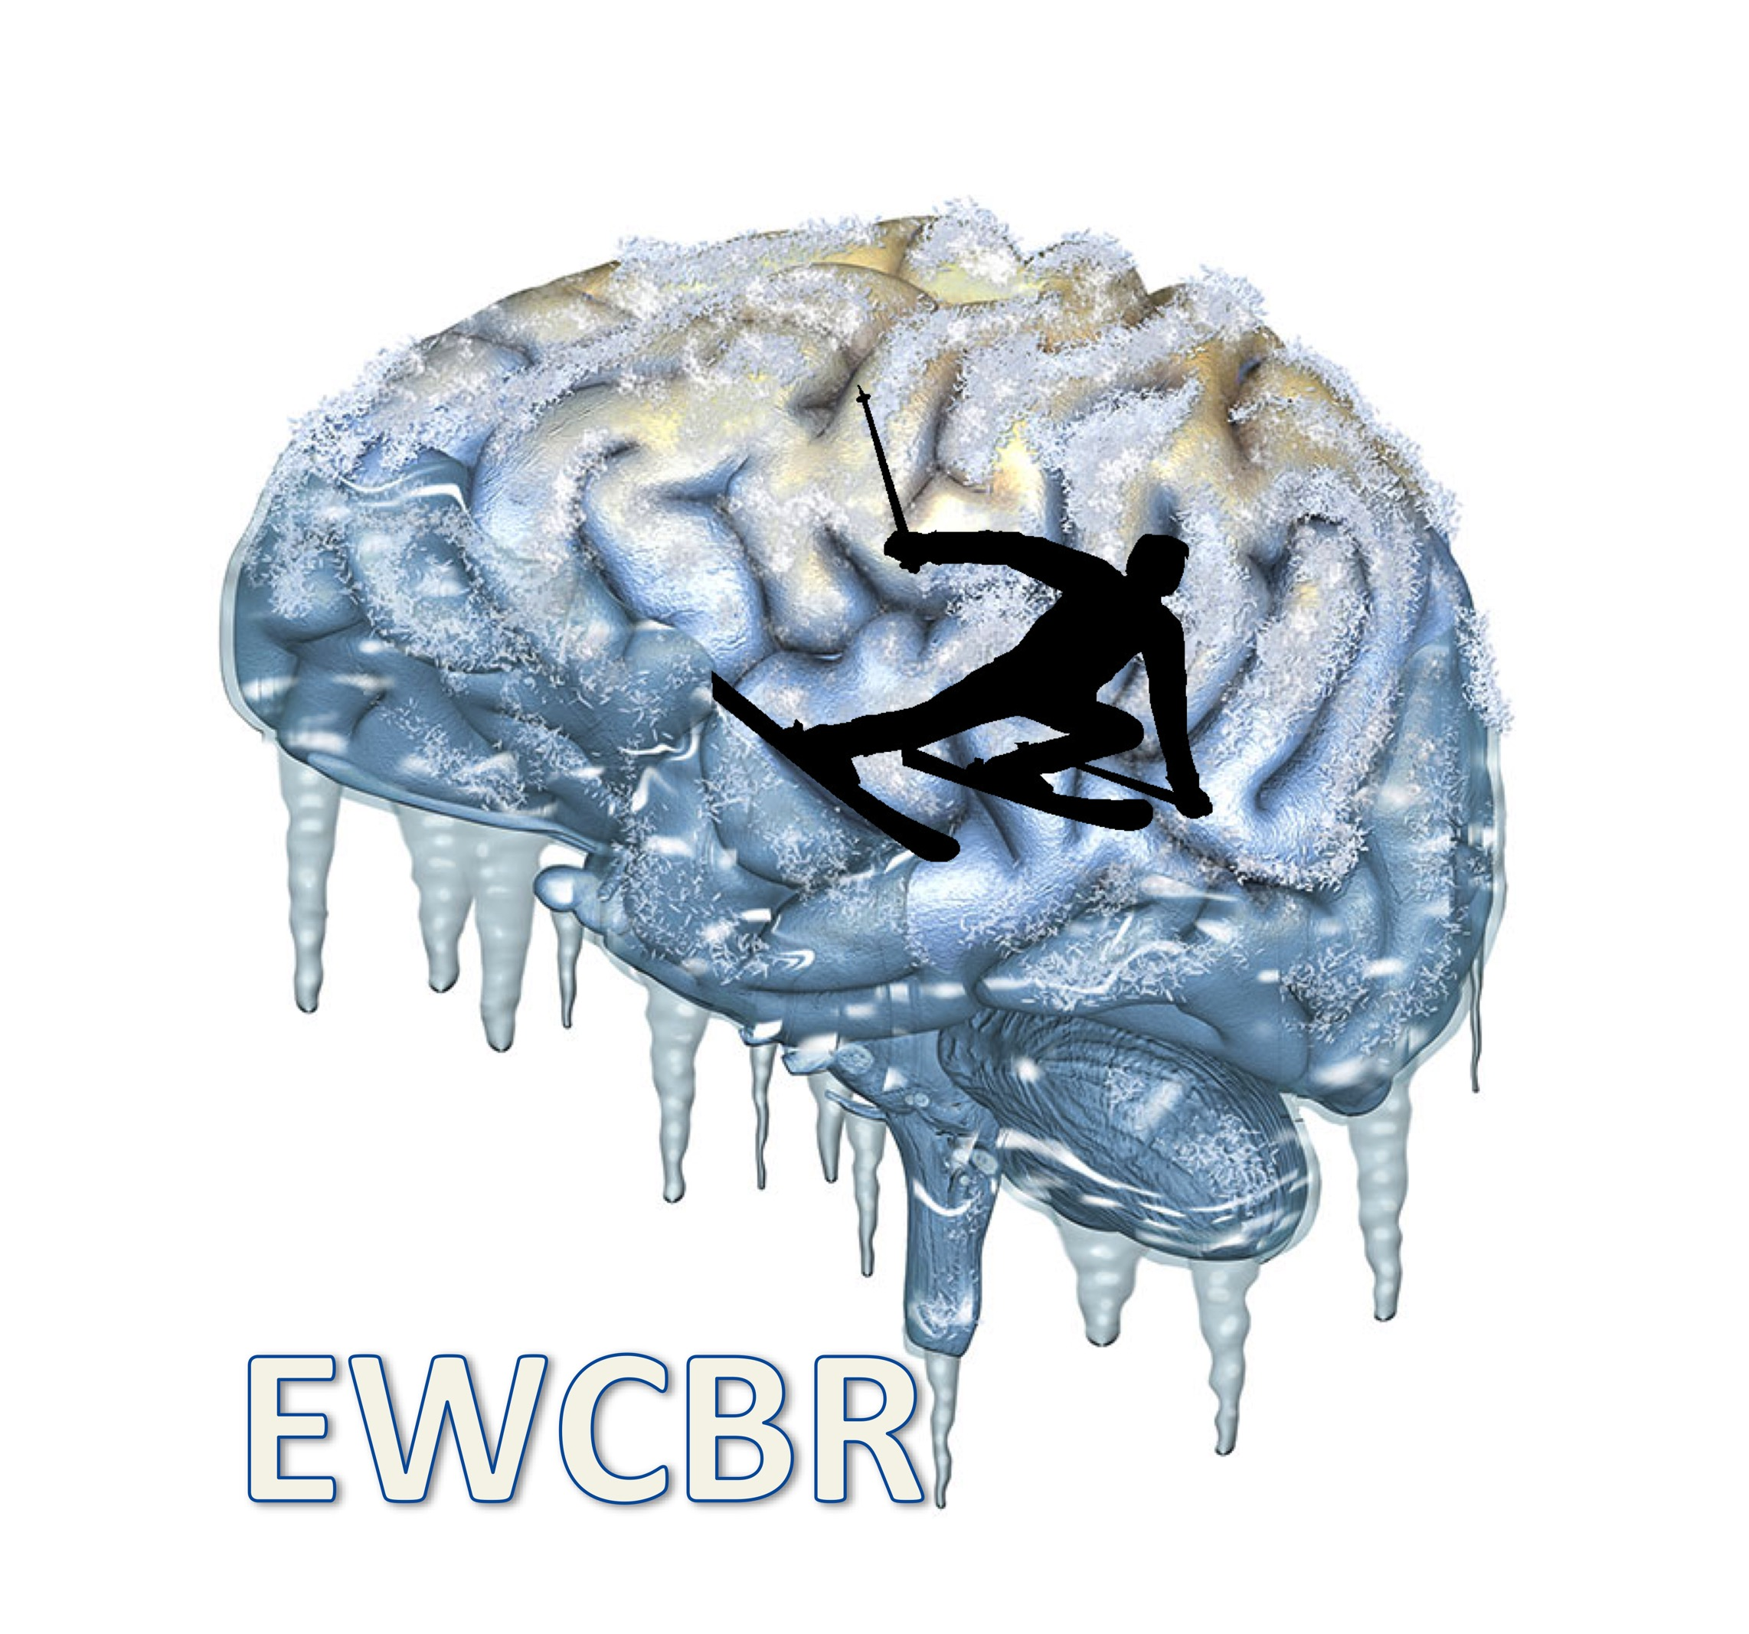
EUROPEAN WINTER CONFERENCE ON BRAIN RESEARCH

41th E.W.C.B.R. / E.B.B.S WINTER CONFERENCE
Switzerland, Eurotel, Les Diablerets
March 4th – March 11th, 2023

SYMPOSIUM PROPOSAL

non-preferred congress days (to be avoided) for the symposium
Monday 6th : [ ]
Tuesday 7th : [ ]
Wednesday 8th : [ ]
Thursday 9th : [ ]
Friday 10th : [ ]

Title of the symposium:

Organizer () :
Email:

Chair(s) :
Email:

Speaker 1, Title, Institution, Title of the talk
Email:
Abstract:

Speaker 2, Title, Institution, Title of the talk
Email:
Abstract:

Speaker 3, Title, Institution, Title of the talk
Email:
Abstract:

Speaker 4, Title, Institution, Title of the talk
Email:
Abstract:

